Business name:
ROYAL DYNASTY FRAGRANCES
Business logo:
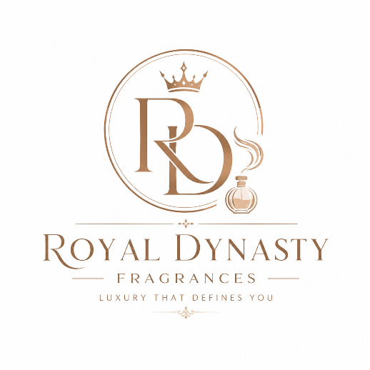
Business color:
White and cream
Business Slogan:
LUXURY FRAGRANCE AT AFFORDABLE PRICE
List of fragrances
- Lattafa
Perfume | Nigeria (₦) | Ghana (GH₵)
Khamrah | ₦48,000–₦62,000 | GH₵400–520
Khamrah Qahwa | ₦55,000–₦69,000 | GH₵460–575
Asad | ₦28,000–₦48,000 | GH₵230–400
Asad Zanzibar | ₦41,000–₦55,000 | GH₵345–460
Fakhar Black | ₦35,000–₦48,000 | GH₵290–400
Yara | ₦28,000–₦41,000 | GH₵230–345
Yara Tous | ₦35,000–₦48,000 | GH₵290–400
Oud for Glory | ₦35,000–₦55,000 | GH₵290–460
Amethyst | ₦35,000–₦48,000 | GH₵290–400
Qaed Al Fursan | ₦28,000–₦41,000 | GH₵230–345

- Afnan
Perfume | Nigeria (₦) | Ghana (GH₵)
Club de Nuit Intense Man | ₦48,000–₦76,000 | GH₵400–630
Club de Nuit Iconic | ₦62,000–₦90,000 | GH₵520–750
Club de Nuit Milestone | ₦62,000–₦90,000 | GH₵520–750
Club de Nuit Sillage | ₦62,000–₦90,000 | GH₵520–750
Urban Man Elixir | ₦62,000–₦90,000 | GH₵520–750
Odyssey Mandarin Sky | ₦48,000–₦69,000 | GH₵400–575
Hunter Intense | ₦41,000–₦55,000 | GH₵345–460
Club de Nuit Woman | ₦41,000–₦69,000 | GH₵345–575

- Masion Alhambra
Perfume | Nigeria (₦) | Ghana (GH₵)
Kismet Angel | ₦41,000–₦62,000 | GH₵345–520
Kismet Magic | ₦41,000–₦62,000 | GH₵345–520
Porto Neroli | ₦35,000–₦55,000 | GH₵290–460
Tobacco Touch | ₦35,000–₦55,000 | GH₵290–460
Bright Peach | ₦35,000–₦55,000 | GH₵290–460
Jean Lowe Immortal | ₦48,000–₦69,000 | GH₵400–575
Lovely Chèrie | ₦41,000–₦62,000 | GH₵345–520

- Rasasi
Perfume | Nigeria (₦) | Ghana (GH₵)
Hawas | ₦48,000–₦76,000 | GH₵400–630
Hawas Ice | ₦55,000–₦83,000 | GH₵460–690
Daarej | ₦35,000–₦55,000 | GH₵290–460
Shuhrah | ₦41,000–₦62,000 | GH₵345–520
La Yuqawam | ₦69,000–₦100,000 | GH₵575–860
- Al Haramain
Perfume | Nigeria (₦) | Ghana (GH₵)
Amber Oud Gold Edition | ₦76,000–₦117,000 | GH₵630–980
Amber Oud Rouge | ₦76,000–₦117,000 | GH₵630–980
Detour Noir | ₦41,000–₦62,000 | GH₵345–520
L'Aventure | ₦55,000–₦83,000 | GH₵460–690

6. Paris Corner (5)
- Khair Pistachio — ₦48,000–₦69,000 | GH₵400–575
- Emir Cedrat Essence — ₦41,000–₦62,000 | GH₵345–520
- Emir Vibrant Vetiver Delight — ₦41,000–₦62,000 | GH₵345–520
- Rifaaqat — ₦48,000–₦69,000 | GH₵400–575
- Nouf — ₦41,000–₦62,000 | GH₵345–520

7. Fragrance World (4)
- Barakkat Rouge 540 — ₦41,000–₦62,000 | GH₵345–520
- Cocktail Intense — ₦41,000–₦62,000 | GH₵345–520
- Imperium — ₦41,000–₦62,000 | GH₵345–520
- Suits — ₦41,000–₦62,000 | GH₵345–520

• Budget (₦25k–₦45k / GH₵220–380): Yara, Asad, Qaed Al Fursan, Fakhar Black, Porto Neroli.
• Mid-range (₦45k–₦70k / GH₵400–600): Khamrah, 9PM, Hawas, Jean Lowe Immortal, Club de Nuit Intense Man.
• Premium (₦70k–₦100k / GH₵600–900): Amber Oud Gold, Club de Nuit Iconic, Turathi Blue, La Yuqawam.

1. Deodorant Sprays

Sure
- Sure Men Quantum Dry
- Sure Men Invisible Ice Fresh
- Sure Women Bright Bouquet
- Sure Women Cotton Dry
- Sure Men Active Dry

Nivea
- Fresh Natural
- Black & White Invisible
- Pearl & Beauty
- Deep Black Carbon
- Dry Comfort

Dove
- Original Spray
- Invisible Dry
- Go Fresh Cucumber
- Pomegranate
- Men+Care Clean Comfort

Rexona
- Invisible Aqua
- Shower Fresh
- Active Protection
- Sport Defence
- Aloe Vera

Degree
- MotionSense Cool Rush
- UltraClear Black+White
- Sexy Intrigue
- Men Adventure
- Men Everest

3. Body Mists

Victoria's Secret
- Bare Vanilla
- Pure Seduction
- Love Spell
- Velvet Petals
- Coconut Passion

Bath & Body Works
- Into The Night
- A Thousand Wishes
- Champagne Toast
- Gingham
- In The Stars

Sol de Janeiro
- Cheirosa 62
- Cheirosa 40
- Cheirosa 68
- Cheirosa 71
- Cheirosa 59

Tree Hut
- Tropic Glow
- Vanilla
- Watermelon
- Moroccan Rose
- Coconut Lime

Ariana Grande
- Cloud Mist
- Sweet Like Candy Mist
- Ari Mist
- Moonlight Mist
- Mod Vanilla Mist

4. Roll-on Deodorants

Nivea
- Pearl & Beauty
- Dry Comfort
- Fresh Natural
- Black & White
- Deep Black Carbon

Dove
- Original
- Invisible Dry
- Cucumber
- Pomegranate
- Go Fresh

Sure
- Invisible Ice
- Bright Bouquet
- Cotton Dry
- Quantum Dry
- Active Dry

Rexona
- Aloe Vera
- Invisible Aqua
- Shower Fresh
- Sport Defence
- Active Protection

Mitchum
- Unscented
- Powder Fresh
- Shower Fresh
- Triple Odor Defense
- Men Sport

Axe
- Dark Temptation
- Apollo
- Black
- Gold
- Phoenix

Adidas
- Ice Dive
- Victory League
- Team Five
- Dynamic Pulse
- Pure Game

Nivea Men
- Fresh Active
- Cool Kick
- Deep
- Sensitive
- Dry Impact

Dove Men+Care
- Clean Comfort
- Extra Fresh
- Minerals & Sage
- Sport Active
- Invisible Dry

Old Spice
- Swagger
- Bearglove
- Wolfthorn
- Fiji
- Captain

7. Top Body Lotion Brands
- Vaseline ⭐⭐⭐⭐⭐
- Nivea ⭐⭐⭐⭐⭐
- Palmer's ⭐⭐⭐⭐⭐
- CeraVe ⭐⭐⭐⭐⭐
- Aveeno ⭐⭐⭐⭐⭐

8. Top Lip Balm Brands
- Laneige ⭐⭐⭐⭐⭐
- Burt's Bees ⭐⭐⭐⭐⭐
- Carmex ⭐⭐⭐⭐⭐
- Nivea ⭐⭐⭐⭐☆
- EOS ⭐⭐⭐⭐☆

9. Top Bathing Soap Brands
- Dove ⭐⭐⭐⭐⭐
- Olay ⭐⭐⭐⭐⭐
- Dettol ⭐⭐⭐⭐⭐
- Irish Spring ⭐⭐⭐⭐☆
- Dr. Bronner's ⭐⭐⭐⭐☆

